MEDIA CONTACTS
Andrew Cauthen | Suzanne Forte
Communications Manager | Public Information Officer
404-371-2806 (o) | 404-371-2709 (o)
470-553-4408 (c) | 470-512-0148 (c)

FOR IMMEDIATE RELEASE
June 26, 2018

DeKalb CEO Nominates Rita Scott to MARTA Board
Scott could become DeKalb’s first African-American woman on board
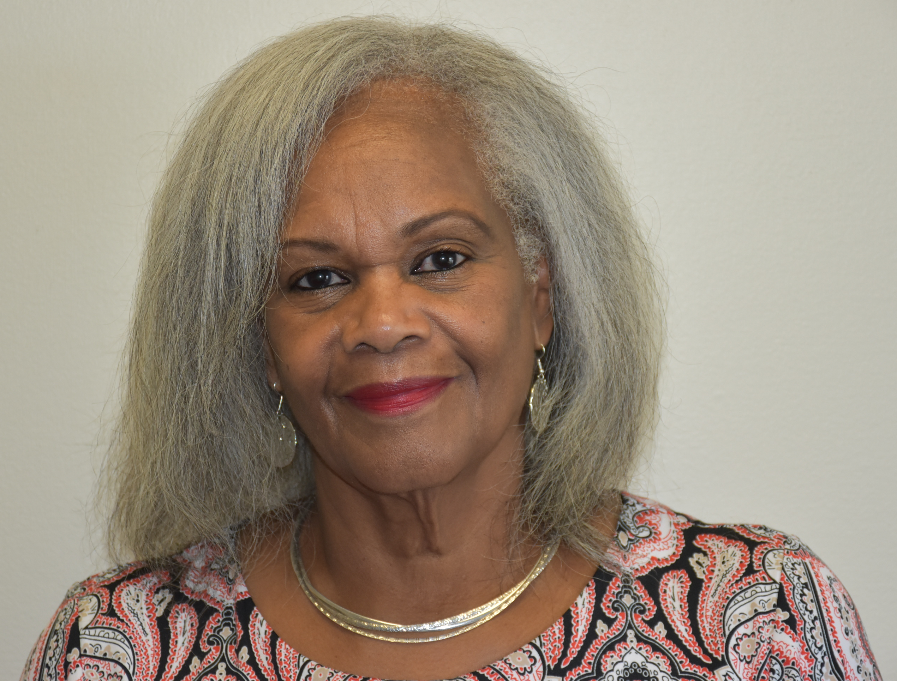
Rita Scott
DECATUR, Ga. – DeKalb County CEO Michael Thurmond has nominated Rita Scott to the MARTA board of directors.

If approved, Scott would become the first African-American woman to represent DeKalb County on the board.

“Rita Scott will advocate for needed transit expansion and improvements throughout DeKalb County, particularly in south DeKalb and other underserved areas,” CEO Thurmond said. “Her experience in governmental affairs and community activism will be an asset to transit officials and riders alike.”

Since 2004, Scott has worked with Communication Workers of America as a political director, lobbying on behalf of workers and workers’ rights.

“I am excited and honored to have the opportunity to serve DeKalb County and our residents by representing them on the MARTA Board,” Scott said. “Transportation is vital to the growth and economic development of all our communities.”

Scott is president of the Carriage Pointe Homeowners Association in Stone Mountain, and a member of the Fourth Congressional District Women and of the Pine Ridge Elementary PTA in Stone Mountain.

Scott holds a bachelor’s degree in business administration from Miami Dade College.

(more)

MARTA Board, page 2

The MARTA Board addresses areas of importance concerning ridership, safety, economics, new technology, government regulations and other issues.

MARTA Board member Robert Dallas, a civil attorney and former director of the Georgia Governor's Office of Highway Safety, was re-nominated to another four-year MARTA board term.

The nominations now will be considered by the DeKalb County Board of Commissioners.

###

