JOINT STATEMENT FROM MR. JOE BEASLEY AND MOUSTAPHA OSMAN, SBI
PUBLIC-PRIVATE PARTNERSHIPS ARE THE KEY TO PROVIDING ACCESS TO CLEAN WATER AND HUMANITARIAN AID IN SOMALILAND
HARGEISA, May 4 2017 - Following a recent visit to Hargeisa and other drought-stricken parts of Somaliland, human rights activist Mr. Joe Beasley today complimented the Government of Somaliland and Somaliland Beverage Industries, the local bottler for Coca-Cola beverages, for their remarkable work in providing access to clean, safe water and humanitarian aid to hundreds of thousands of Somalilanders.
Thanks to the first two interventions through its Replenish Africa Initiative (RAIN), the Coca-Cola Africa Foundation and Somaliland Beverage Industries (SBI) have ensured that 220,000 Somailanders have already gained improved access to clean water since 2013; the drinking water supply in Burco has been increased by 81%; and safe water has been provided to the settlements for Internally Displaced Persons (IDP) for the first time.
In addition, SBI has already supplied over 3 million liters of water to vulnerable communities in Central Somaliland, with a further 2 million liters to be supplied to drought ravaged areas of the country.
“Coca-Cola is a true leader in water stewardship and proves the power of collaboration between the private sector, government and civil society”, said Mr. Beasley, who applauded the partnership of the Ministries of National Planning and Water Resources, the Hargeisa Water Agency, Terre Solidali and others.“ They share a long-term commitment to Somaliland and will extend the RAIN initiative in Somaliland through 2020”, he continued.
Project construction on the initial water storage, utility strengthening and baseline survey activities for the next phase has already started. RAIN 2020 Somaliland will support infrastructure expansion to improve water access for nearly all the unserved population of Hargeisa, improving water access for nearly 530,000 more people and extending water coverage from 34% to 81% percent of the total city population. By 2020, the humanitarian impact of the RAIN program will reach over 60,000 Internally Displaced Persons, which is 71% of all the IDPs living in Somaliland.
Further humanitarian intervention by SBI includes the delivery of lifesaving medication to the MAS Children Hospital, and to Hargeisa’s largest maternity hospital, Edna Aden, where SBI also provides expert technical expertise to help with the testing and chlorination of water. Outside the city, SBI has moved immediately to respond to the outbreak of acute watery diarrhea in the east of the country: a meeting was convened this week between SBI’s Managing Director, Moustapha Osman Guelleh, and the State Minister of Health, Amb. Mahmoud Adam Jama and his senior advisers and directors. Together they finalized a plan with Citihope’s Paul Moore II, SBI’s implementing partner in the supply of medication, to expedite the procurement and delivery of vital medicines to the Ministry.
Mr. Beasley also visited the SBI bottling plant in Jaleelo, which was opened in 2012 with USD 17MM investment, and described it as “a jewel in the desert” with best-in-class operating standards. Moustapha Osman Guelleh, Managing Director of SBI, noted that the Coca-Cola system employs over 300 people directly and contributes to the livelihoods of ten times that number of people throughout its supply chain.
SBI’s Mr. Osman noted that the RAIN 2020 Somaliland project will have attracted the highest level of co-financing for any project in RAIN’s history, leveraging The Coca-Cola Africa Foundation’s investment of $6.8MM to attract over $40MM from KfW, UN-Habitat, and the European Union.
On the morning of the 30th April, Mr Beasley and Mr Osman visited two of the sites on which two large water storage reservoirs are being built. This is part of the the RAIN 2020 project.
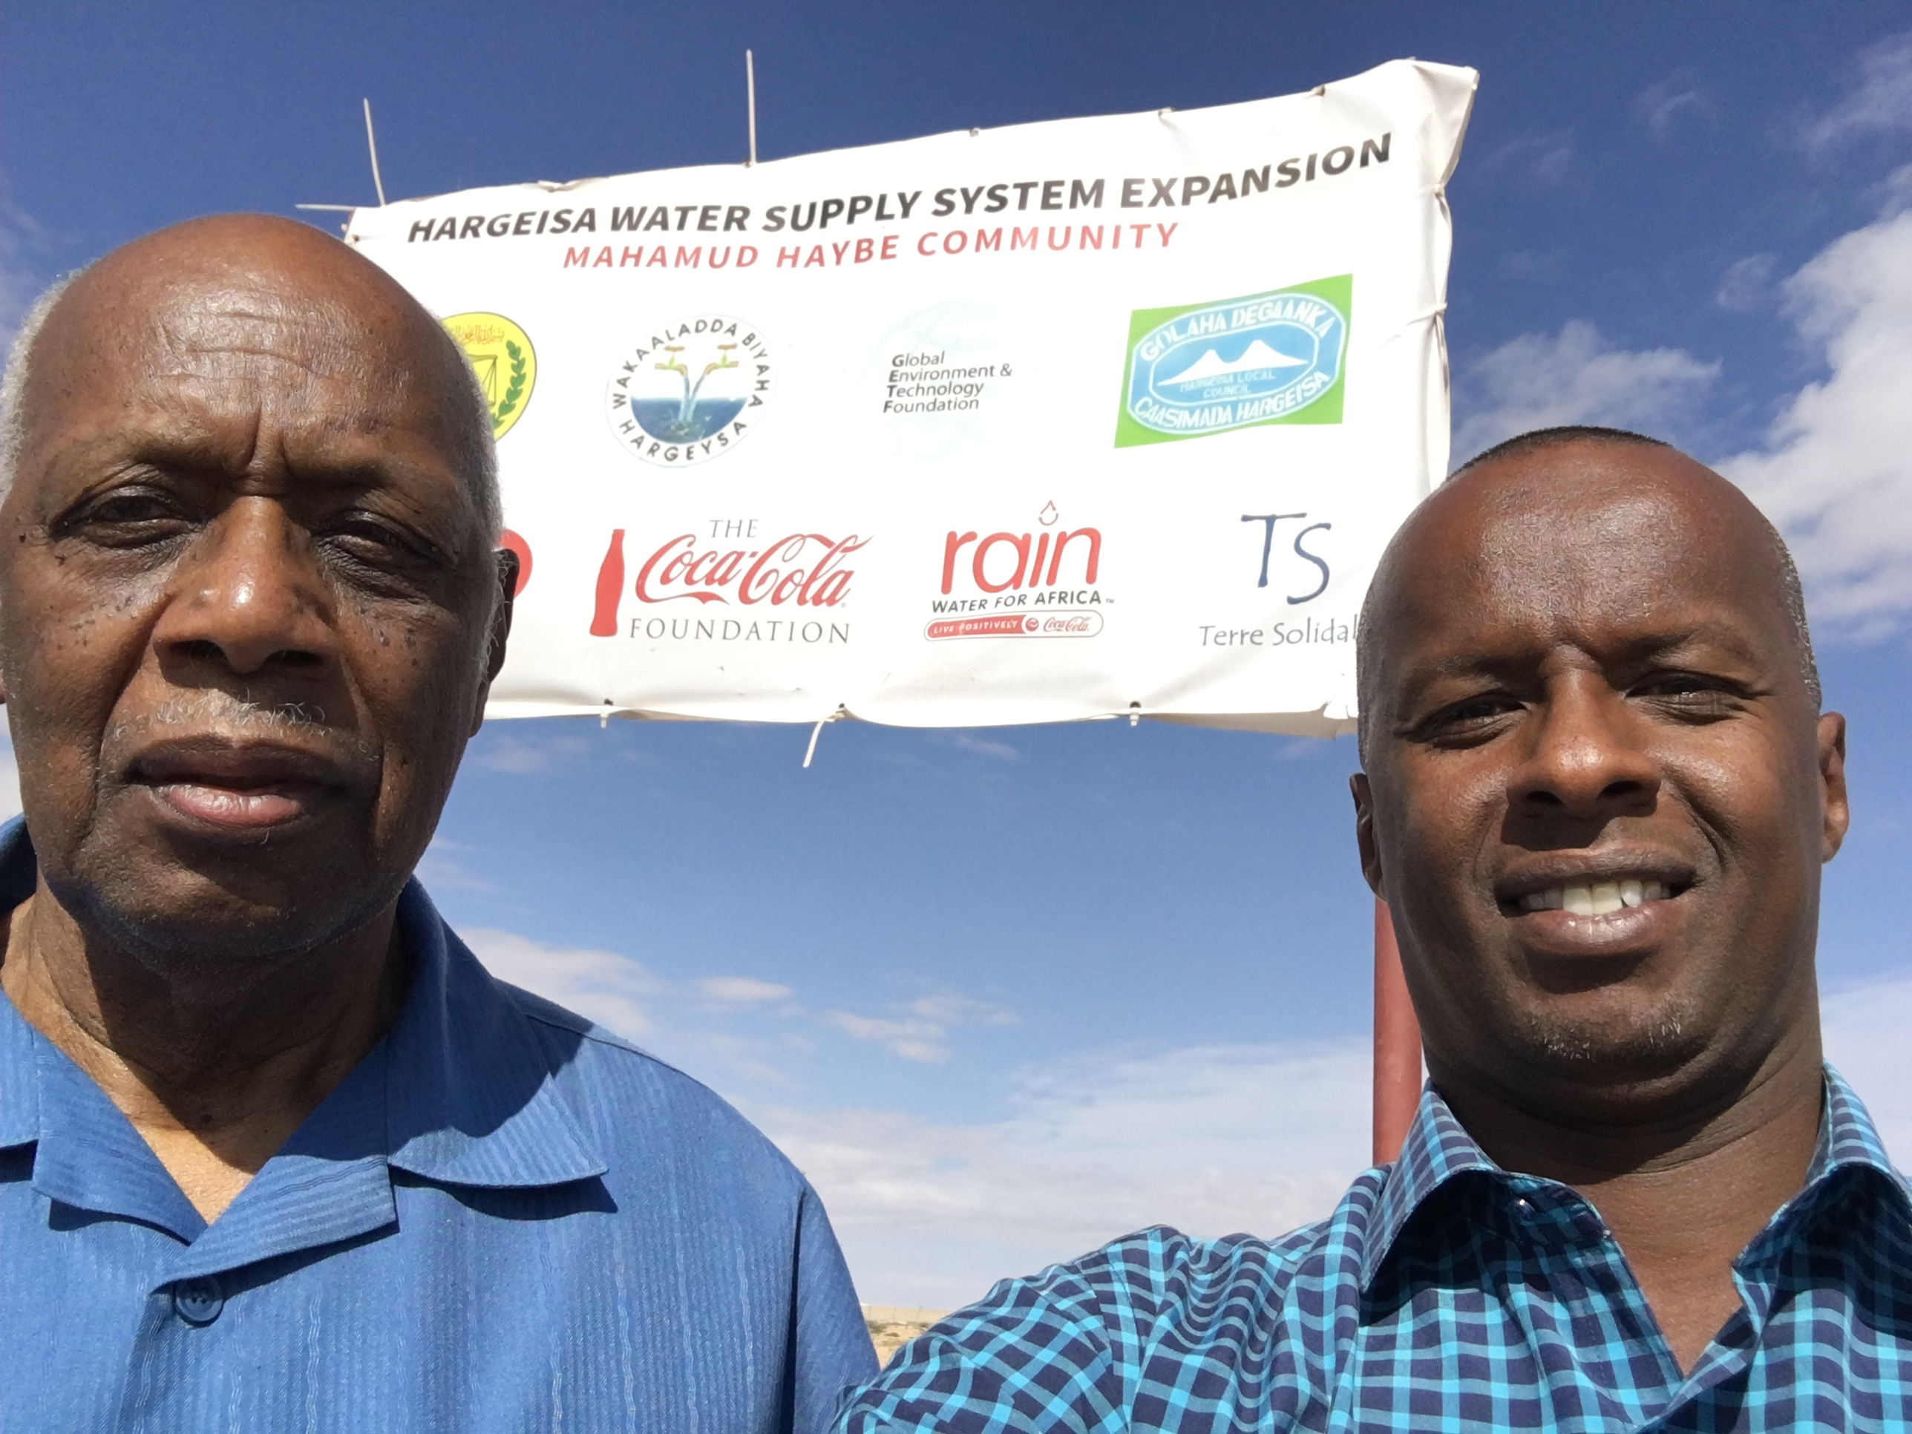
Mr. Osman concluded, “We will not let up in our commitment to support the communities of Somaliland. We will continue the dialogue around the sustainable use of water and replenishment with the local authorities, civil society and funders. We will continue to respond quickly and compassionately to those in need, whether providing life-saving medicine through CitiHope or consignments of fortified foodstuffs to undernourished children and families through USAID. We are most effective when we work together, as one, and we thank the Ministry of National Planning, in particular, for their strategic guidance and Mr. Joe Beasley for his passionate support of the rights of all Somalilanders.”
<END>

